### Facade Design Pattern

The Facade design pattern is a structural pattern that provides a simplified interface to a complex subsystem. This pattern defines a higher-level interface that makes the subsystem easier to use by hiding its complexity. It helps in reducing the dependencies of outside code on the inner workings of a complex system, promoting loose coupling and easier maintenance.

### Definition

The Facade pattern offers a unified and simplified interface to a set of interfaces in a subsystem, making the subsystem easier to use. It allows clients to interact with the subsystem through a single, unified interface, rather than dealing with multiple interfaces.

**When to use:** When we have to hide the system complexities from the client.

**Imp:** Note that the **Façade is** **optional**, client is not restricted to interact with façade only. If wanted, client can also interact with the background complexities i.e. classes.

All the complexity and logic go in Façade layer.

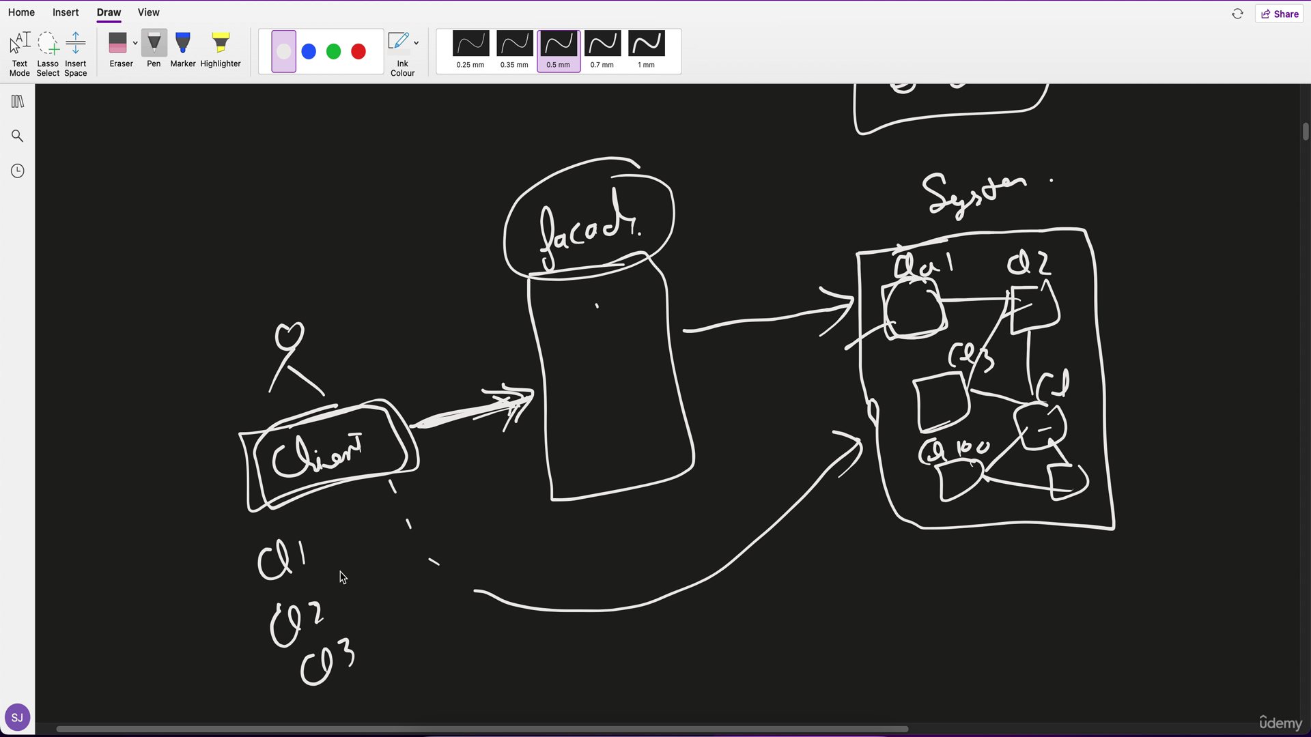

### Example

Consider a complex system for managing a home theatre setup with various components like DVD players, projectors, and sound systems.

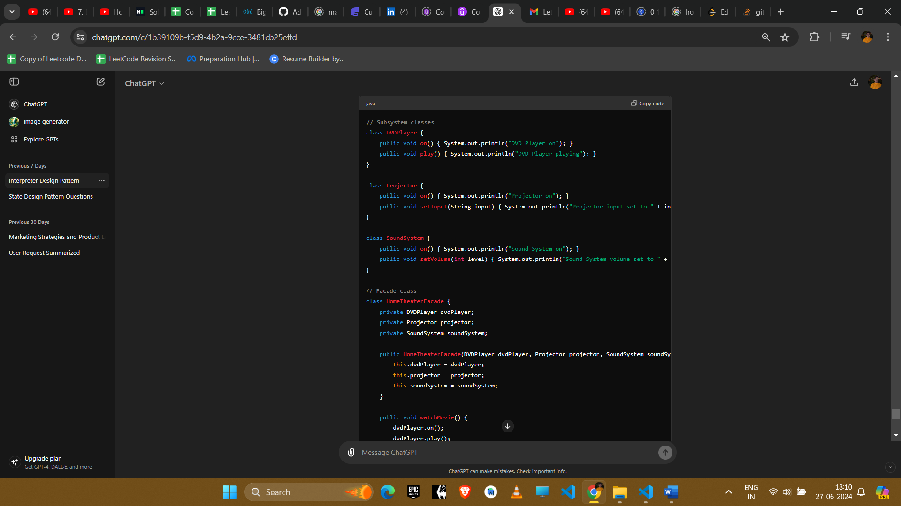

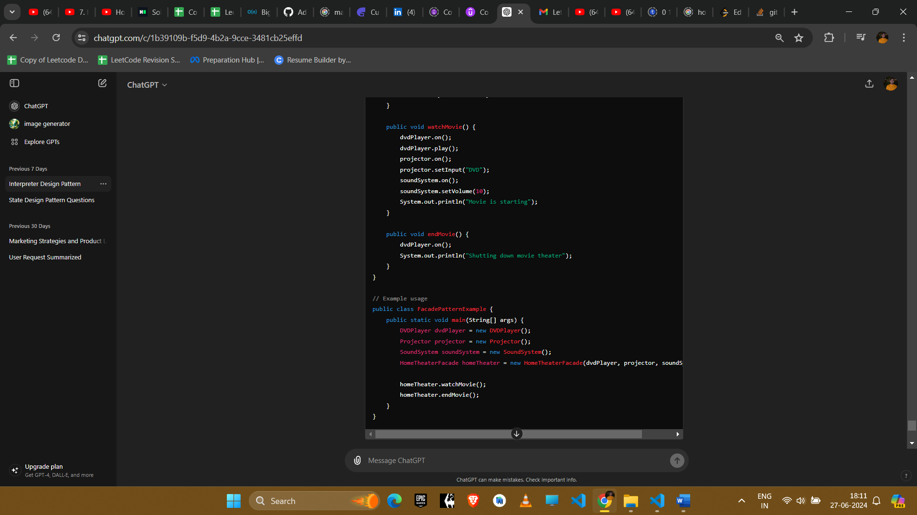

**Explanation**

1. **Subsystem Classes**: DVDPlayer, Projector, and SoundSystem represent different parts of the home theater system.
2. **Facade Class**: HomeTheaterFacade provides a simplified interface to interact with the complex subsystem of home theater components. It encapsulates the interactions between different components and provides higher-level methods like watchMovie() and endMovie().

**Example Uses in Amazon Interviews**

1. **Simplifying API Usage**
   * **Scenario**: Providing a simple interface to a complex library or framework.
   * **Implementation**: Use a facade to create a simpler API that wraps the complex functionality of the library, making it easier for clients to use.
2. **System Initialization**
   * **Scenario**: Initializing a system with multiple complex subsystems.
   * **Implementation**: Use a facade to encapsulate the initialization logic of various subsystems, providing a simple method to initialize the entire system.
3. **Cross-System Interactions**
   * **Scenario**: Managing interactions between multiple subsystems.
   * **Implementation**: Use a facade to handle the interactions between different subsystems, reducing the dependencies between them and simplifying the client code.
4. **Migration to New Systems**
   * **Scenario**: Migrating to a new system while maintaining compatibility with existing code.
   * **Implementation**: Use a facade to provide a consistent interface to the new system, allowing existing code to interact with the new system without changes.

**Conclusion**

The Facade pattern is useful for simplifying the interaction with complex subsystems, providing a clear and easy-to-use interface while hiding the complexity of the underlying components. It promotes loose coupling and makes the system easier to maintain and understand, making it a valuable tool in many software development scenarios.